Mod:-2 Validation and Testing
Authentication :-
Test Case 1: Successful login as a Passenger.
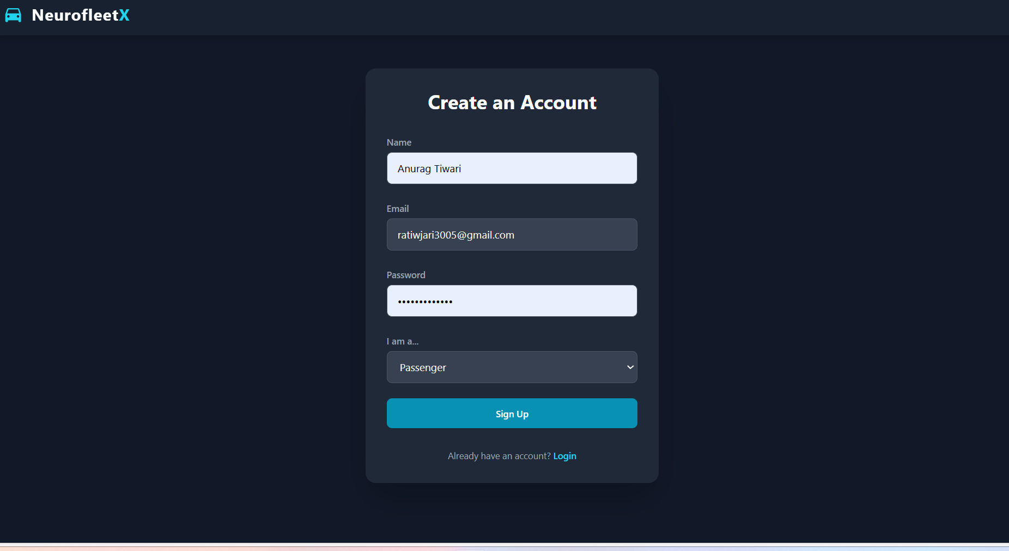
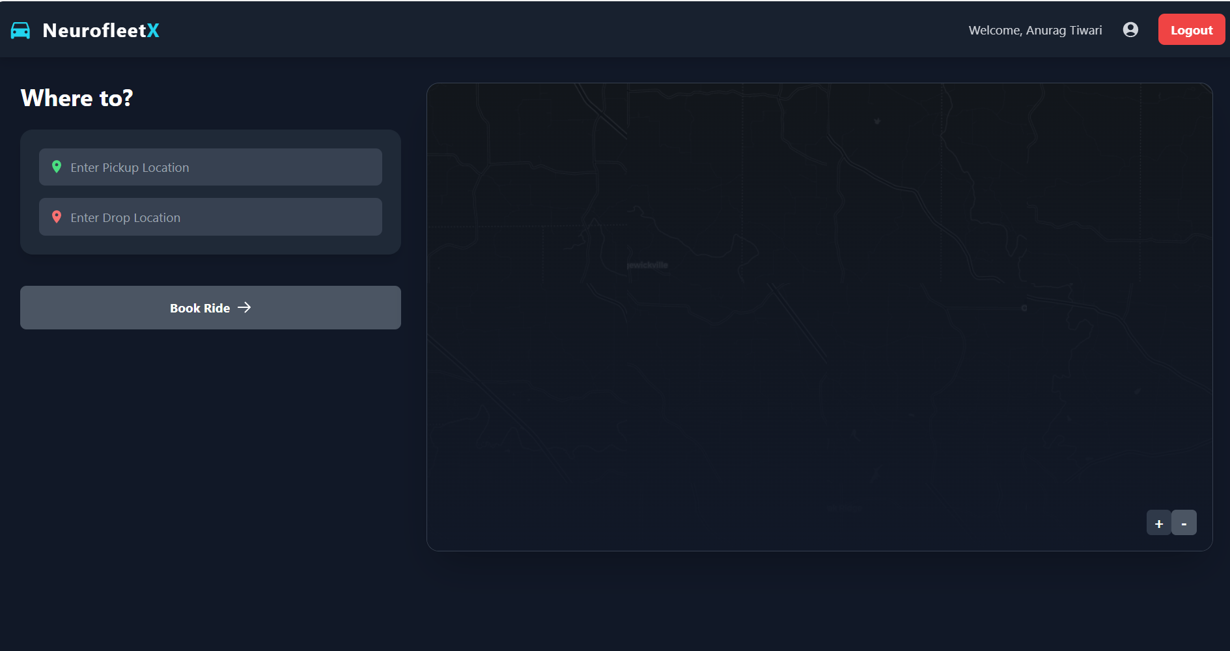
Passenger Dashboard
Test Case 2: Successful login as a Fleet Owner.
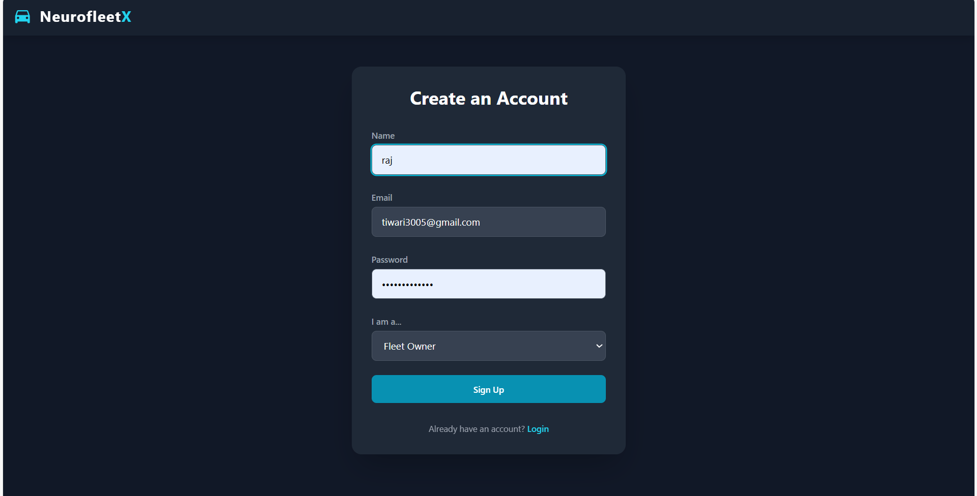
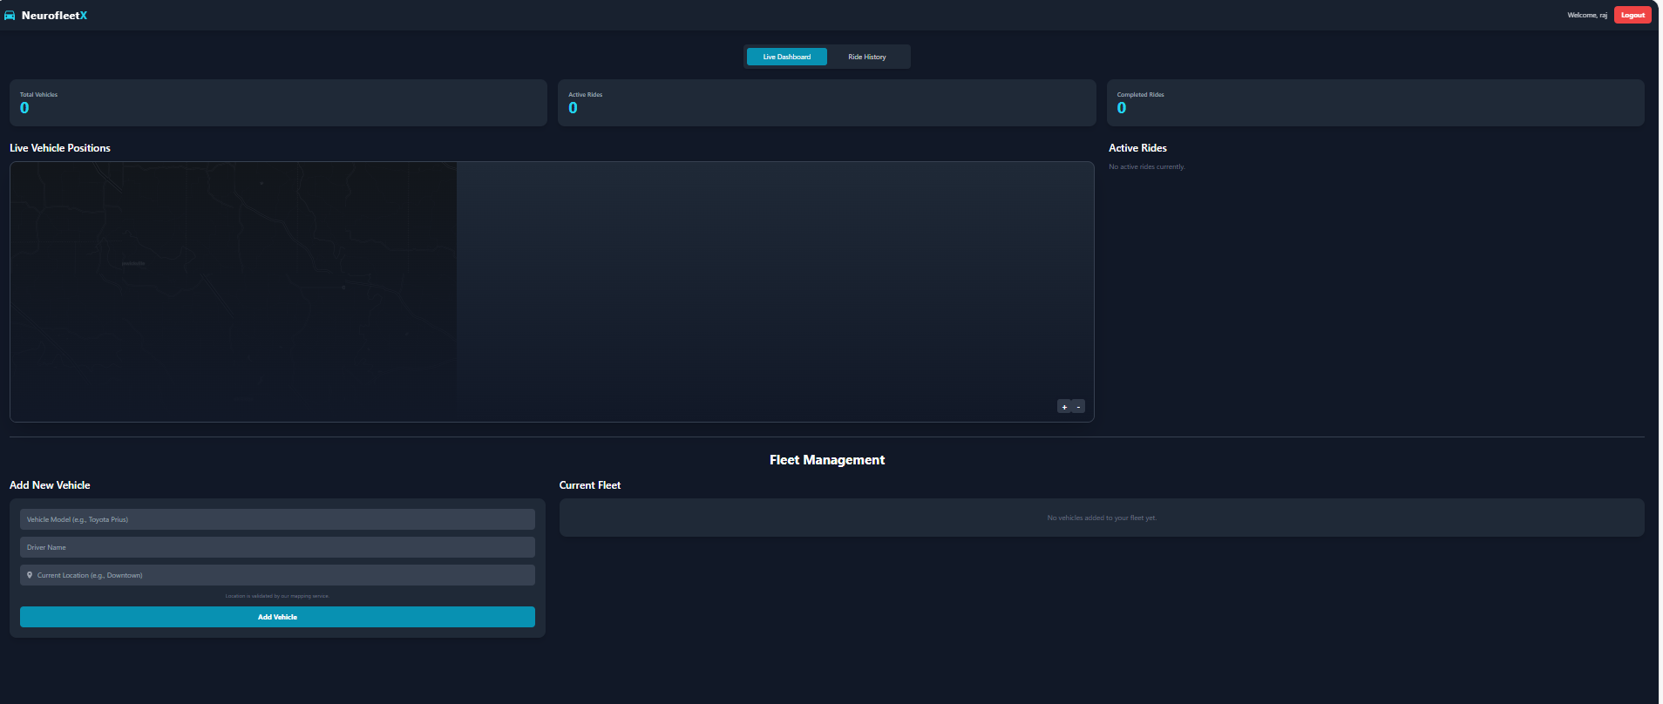
Fleet Owner Dashboard
Test Case 3: Failed login with an incorrect password.
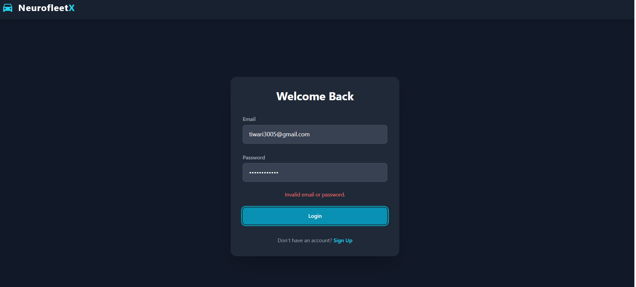
Test Case 4: Attempt to register with an email that is already in use.
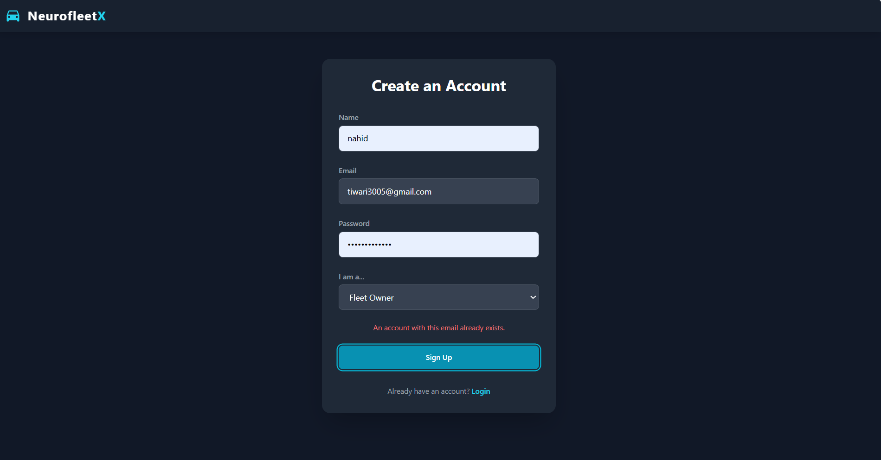

Passenger:-
Test Case 1: View available vehicles on the home page map.
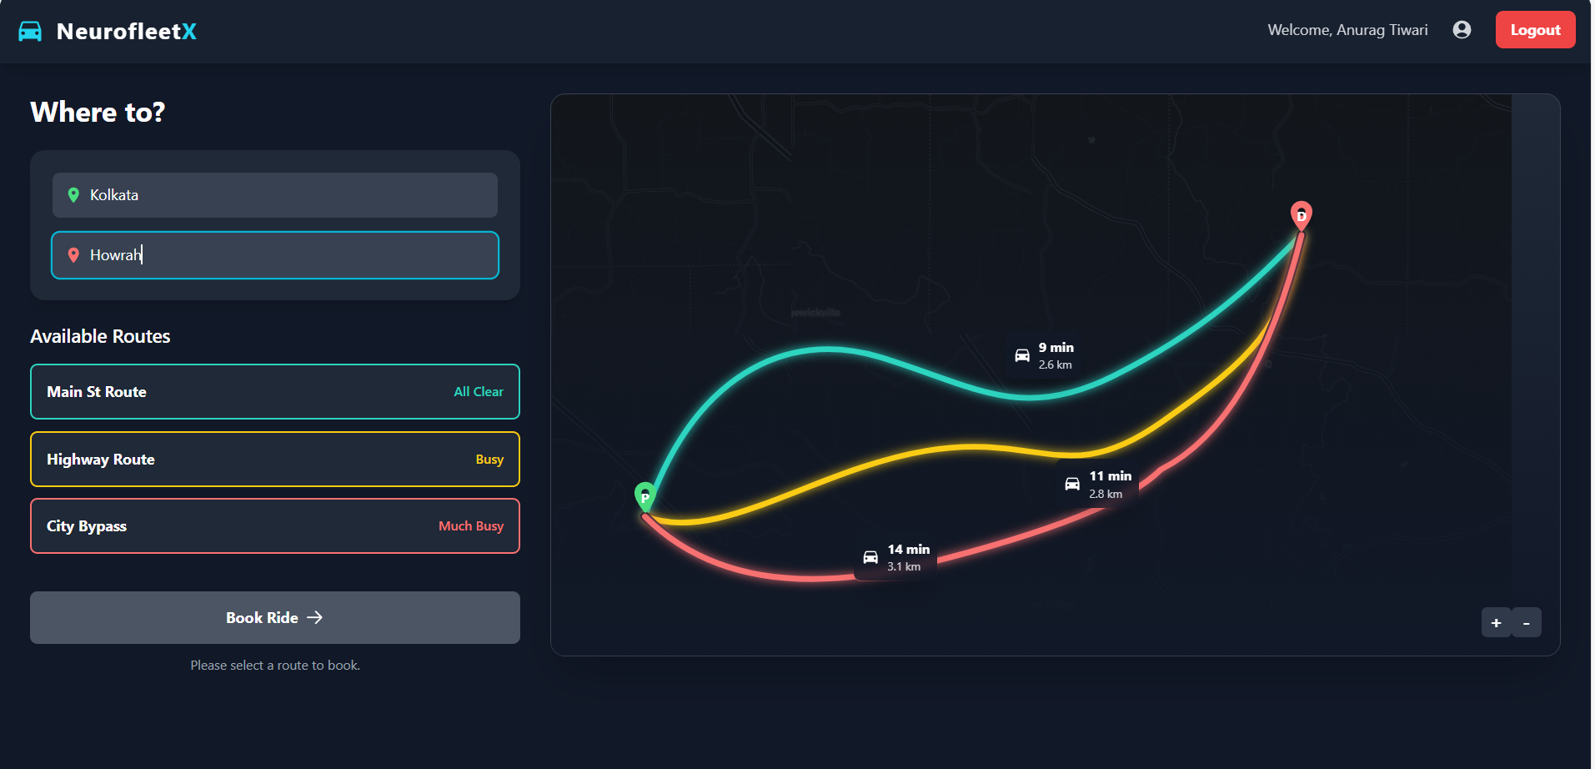

Test Case 2: Generate multiple route options by entering pickup and drop-off locations.

Test Case 3: Select a valid route and successfully book a ride.
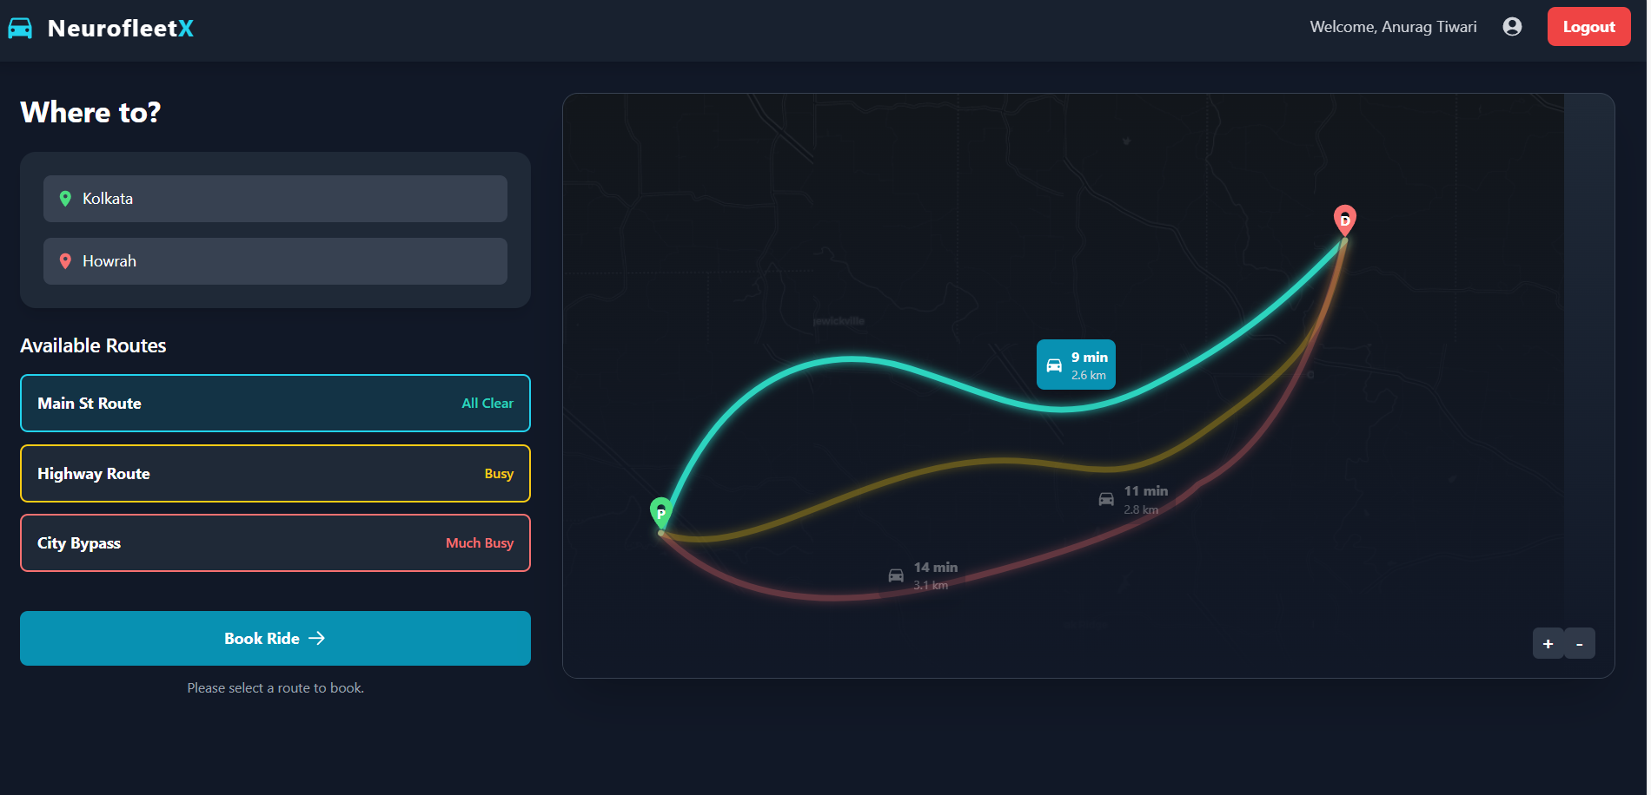
Selection of All clear route
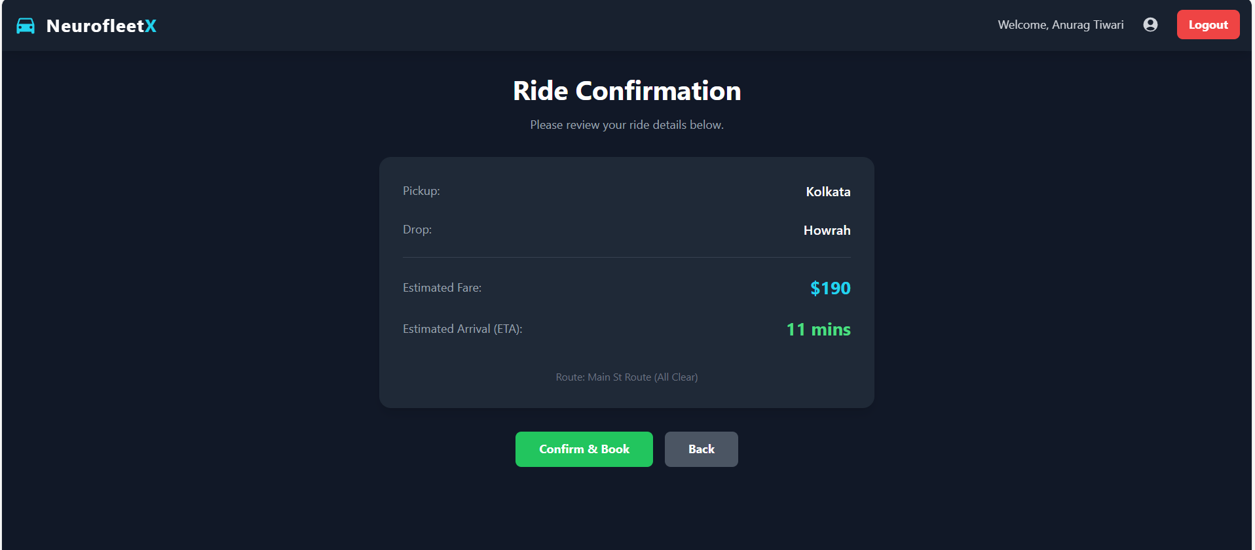
After click on “Confirm & Book” the ride is booked successfully
Test Case 4: Cancel an in-progress ride.
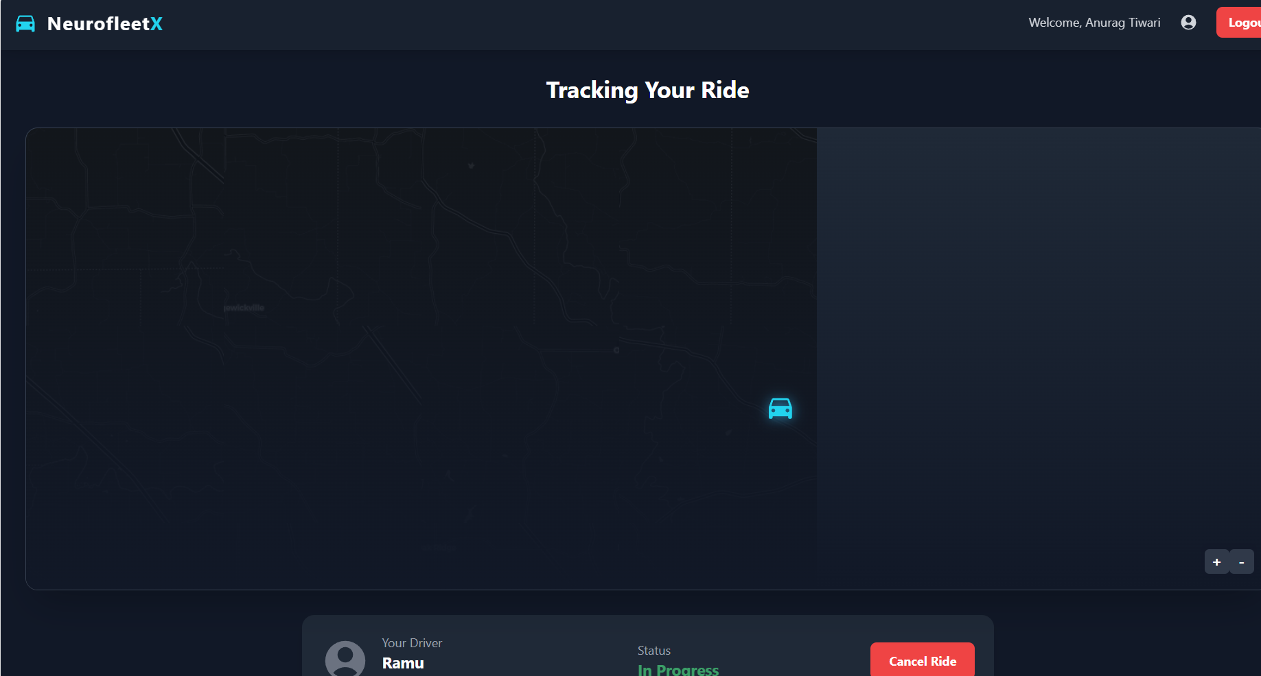

Test Case 5: View user details on the Profile page.
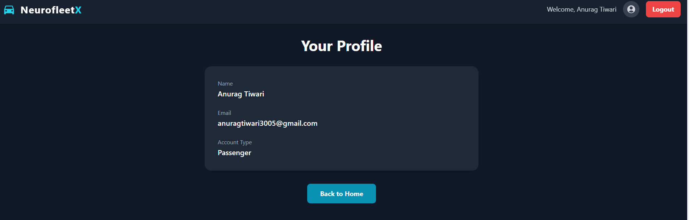

Fleet Owner:-
Test Case 1: Add a new vehicle and see it appear instantly on the fleet list.
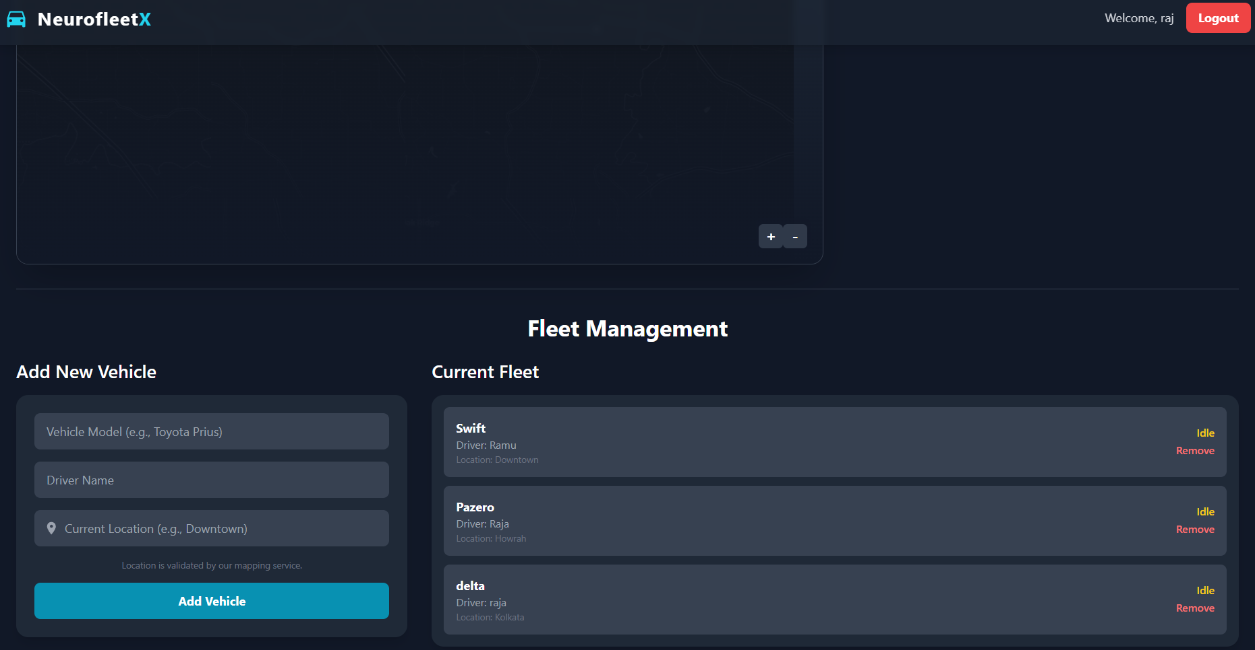
Test Case 2: Remove a vehicle and see it disappear from the map and the fleet list.
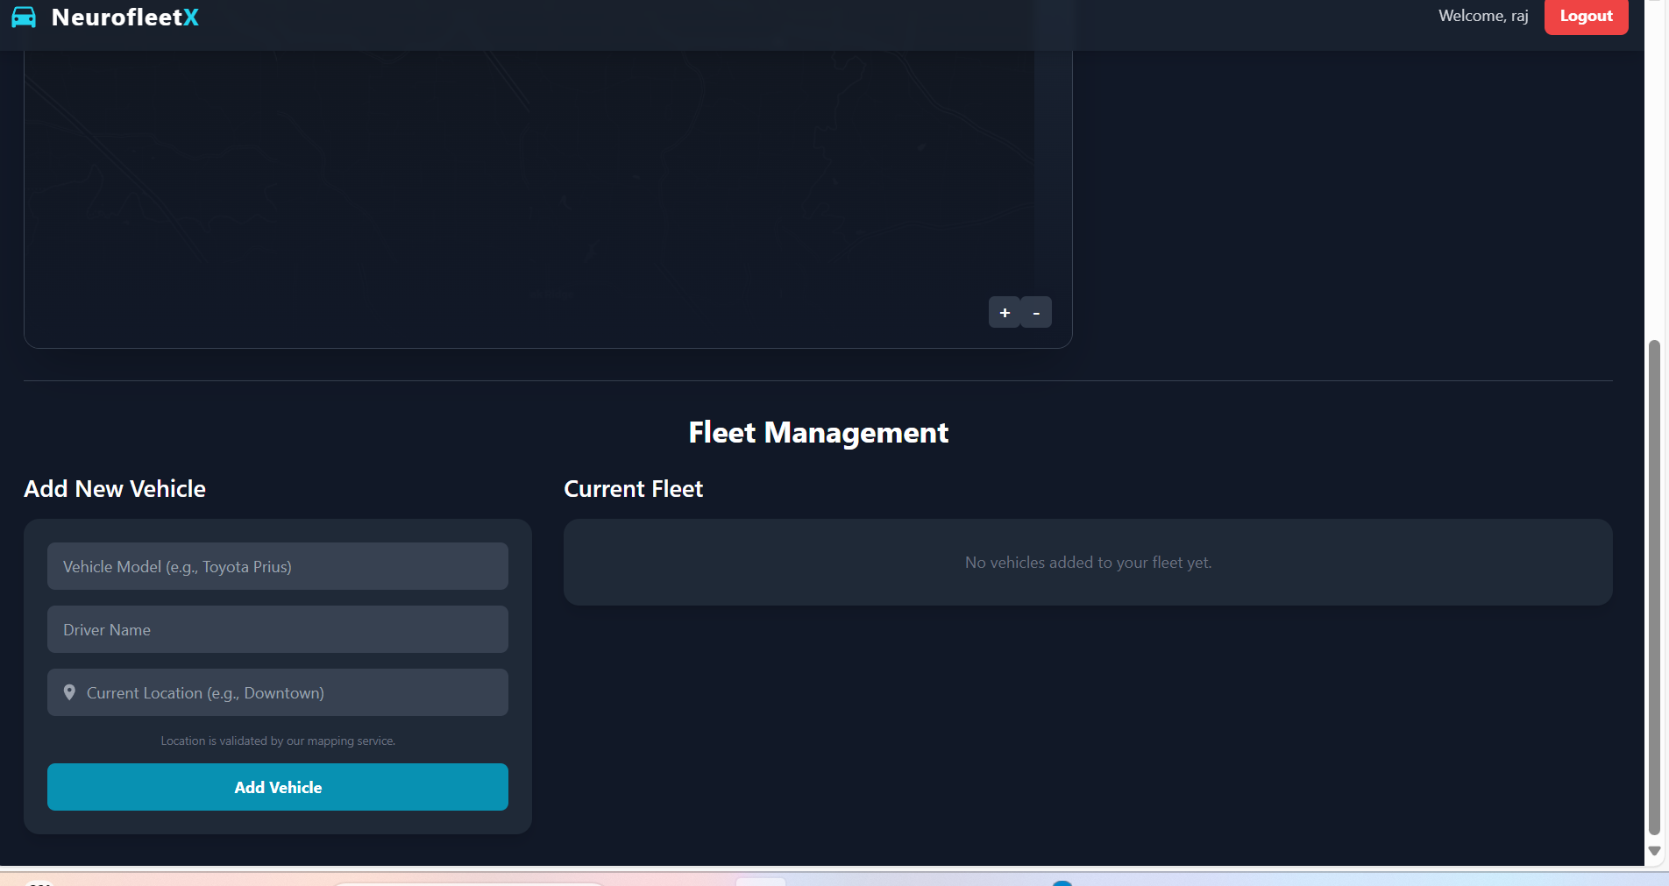
Test Case 3: Confirm that a completed or Cancelled passenger ride appears correctly in the "Ride History" table.
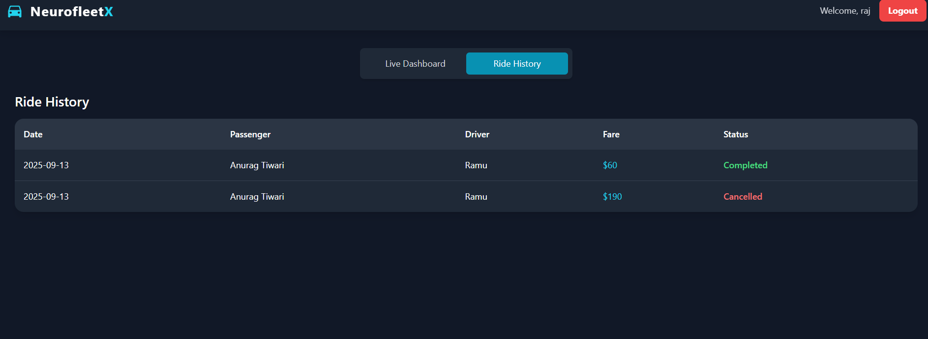

Test Case 4: View Total active vehicle, Active Rides and Completed Rides Live Dashboard page.
